**Spring REST using Spring Boot 3**

1. **spring-rest-handson**

**Q>Create a Spring Web Project using Maven**

**Code:**

package com.cognizant.spring_learn;  
import org.slf4j.Logger;  
import org.slf4j.LoggerFactory;  
  
import org.springframework.boot.SpringApplication;  
import org.springframework.boot.autoconfigure.SpringBootApplication;  
  
@SpringBootApplication  
public class SpringLearnApplication {  
 private static final Logger *LOGGER* = LoggerFactory.*getLogger*(SpringLearnApplication.class);  
 public static void main(String[] args) {  
 SpringApplication.*run*(SpringLearnApplication.class, args);  
 *LOGGER*.info("Inside Main()");  
 }  
  
}

**Output**



**Q>Spring Core – Load Country from Spring Configuration XML**

**Code:**

SpringLearnApplication.java

package com.cognizant.spring_learn;  
import org.slf4j.Logger;  
import org.slf4j.LoggerFactory;  
  
import org.springframework.boot.SpringApplication;  
import org.springframework.boot.autoconfigure.SpringBootApplication;  
import org.springframework.context.ApplicationContext;  
import org.springframework.context.support.ClassPathXmlApplicationContext;  
  
@SpringBootApplication  
public class SpringLearnApplication {  
 private static final Logger *LOGGER* = LoggerFactory.*getLogger*(SpringLearnApplication.class);  
 public static void main(String[] args) {  
 SpringApplication.*run*(SpringLearnApplication.class, args);  
 *LOGGER*.info("Inside Main()");  
 *displayCountry*();  
  
 }  
 public static void displayCountry() {  
 ApplicationContext context = new ClassPathXmlApplicationContext("country.xml");  
 Country country = context.getBean("country", Country.class);  
 *LOGGER*.debug("Country : {}", country.toString());  
 }  
  
}

Country.java

package com.cognizant.spring_learn;  
import org.slf4j.Logger;  
import org.slf4j.LoggerFactory;  
public class Country {  
 private static final Logger *LOGGER* = LoggerFactory.*getLogger*(Country.class);  
  
 private String code;  
 private String name;  
  
 public Country() {  
 *LOGGER*.debug("Inside Country Constructor.");  
 }  
  
 public String getCode() {  
 *LOGGER*.debug("Inside getCode()");  
 return code;  
 }  
  
 public void setCode(String code) {  
 *LOGGER*.debug("Inside setCode()");  
 this.code = code;  
 }  
  
 public String getName() {  
 *LOGGER*.debug("Inside getName()");  
 return name;  
 }  
  
 public void setName(String name) {  
 *LOGGER*.debug("Inside setName()");  
 this.name = name;  
 }  
  
 @Override  
 public String toString() {  
 return "Country{" +  
 "code='" + code + '\'' +  
 ", name='" + name + '\'' +  
 '}';  
 }  
}

country.xml

<?xml version="1.0" encoding="UTF-8"?>  
<beans xmlns="http://www.springframework.org/schema/beans"  
 xmlns:xsi="http://www.w3.org/2001/XMLSchema-instance"  
 xsi:schemaLocation="http://www.springframework.org/schema/beans  
 https://www.springframework.org/schema/beans/spring-beans.xsd">  
  
 <bean id="country" class="com.cognizant.spring_learn.Country">  
 <property name="code" value="IN"/>  
 <property name="name" value="India"/>  
 </bean>  
</beans>

**Output**

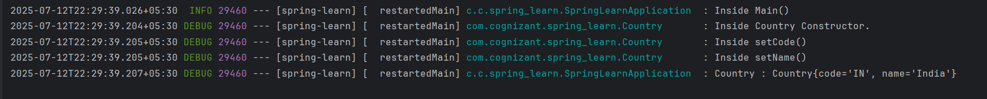

Q> **Hello World RESTful Web Service**

Code:

HelloController.java

package com.cognizant.spring_learn.controller;  
  
import org.slf4j.Logger;  
import org.slf4j.LoggerFactory;  
import org.springframework.web.bind.annotation.GetMapping;  
import org.springframework.web.bind.annotation.RestController;  
  
@RestController  
public class HelloController {  
  
 private static final Logger *LOGGER* = LoggerFactory.*getLogger*(HelloController.class);  
  
 @GetMapping("/hello")  
 public String sayHello() {  
 *LOGGER*.info("START sayHello()");  
 String message = "Hello World!!";  
 *LOGGER*.info("END sayHello()");  
 return message;  
 }  
}

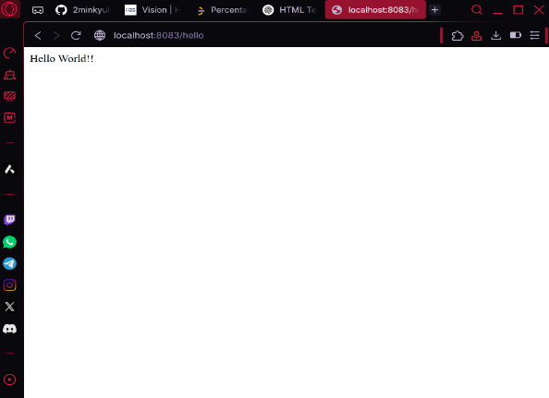**Output**



**Q4>REST - Country Web Service**

**Code:**

CountryController.java

package com.cognizant.spring_learn.controller;  
  
import com.cognizant.spring_learn.Country;  
import org.slf4j.Logger;  
import org.slf4j.LoggerFactory;  
import org.springframework.context.ApplicationContext;  
import org.springframework.context.support.ClassPathXmlApplicationContext;  
import org.springframework.web.bind.annotation.RequestMapping;  
import org.springframework.web.bind.annotation.RestController;  
  
@RestController  
public class CountryController {  
  
 private static final Logger *LOGGER* = LoggerFactory.*getLogger*(CountryController.class);  
  
 @RequestMapping("/country")  
 public Country getCountryIndia() {  
 *LOGGER*.info("START getCountryIndia()");  
 ApplicationContext context = new ClassPathXmlApplicationContext("country.xml");  
 Country country = (Country) context.getBean("country");  
 *LOGGER*.info("END getCountryIndia()");  
 return country;  
 }  
}

**Output**

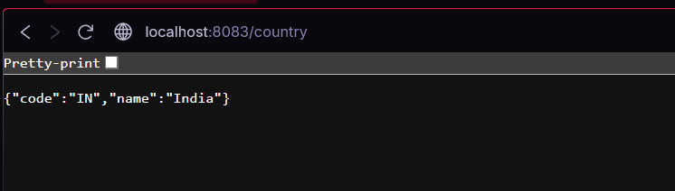

**Q5>** **REST - Get country based on country code**

**Code:**

**c**ountry.xml

<?xml version="1.0" encoding="UTF-8"?>

<beans xmlns="http://www.springframework.org/schema/beans"

xmlns:xsi="http://www.w3.org/2001/XMLSchema-instance"

xsi:schemaLocation="

http://www.springframework.org/schema/beans

https://www.springframework.org/schema/beans/spring-beans.xsd">

<bean id="countryList" class="java.util.ArrayList">

<constructor-arg>

<list>

<bean class="com.cognizant.spring_learn.Country">

<property name="code" value="IN"/>

<property name="name" value="India"/>

</bean>

<bean class="com.cognizant.spring_learn.Country">

<property name="code" value="US"/>

<property name="name" value="United States"/>

</bean>

<bean class="com.cognizant.spring_learn.Country">

<property name="code" value="JP"/>

<property name="name" value="Japan"/>

</bean>

<bean class="com.cognizant.spring_learn.Country">

<property name="code" value="DE"/>

<property name="name" value="Germany"/>

</bean>

</list>

</constructor-arg>

</bean>

</beans>

CountryService.java

package com.cognizant.spring_learn.service;

import com.cognizant.spring_learn.Country;

import org.springframework.context.ApplicationContext;

import org.springframework.context.support.ClassPathXmlApplicationContext;

import org.springframework.stereotype.Service;

import java.util.List;

@Service

public class CountryService {

public Country getCountry(String code) {

ApplicationContext context = new ClassPathXmlApplicationContext("country.xml");

List<Country> countries = context.getBean("countryList", List.class);

return countries.stream()

.filter(c -> c.getCode().equalsIgnoreCase(code))

.findFirst()

.orElse(null); // Or throw exception if you prefer

}

}

CountryController.java

package com.cognizant.spring_learn.controller;

import com.cognizant.spring_learn.Country;

import com.cognizant.spring_learn.service.CountryService;

import org.slf4j.Logger;

import org.slf4j.LoggerFactory;

import org.springframework.beans.factory.annotation.Autowired;

import org.springframework.web.bind.annotation.*;

@RestController

public class CountryController {

private static final Logger LOGGER = LoggerFactory.getLogger(CountryController.class);

@Autowired

private CountryService countryService;

@GetMapping("/country/{code}")

public Country getCountry(@PathVariable String code) {

LOGGER.info("START getCountry() with code: {}", code);

Country country = countryService.getCountry(code);

LOGGER.info("END getCountry()");

return country;

}

}

Country.java

package com.cognizant.spring_learn;

public class Country {

private String code;

private String name;

public Country() {}

public String getCode() {

return code;

}

public void setCode(String code) {

this.code = code;

}

public String getName() {

return name;

}

public void setName(String name) {

this.name = name;

}

@Override

public String toString() {

return "Country [code=" + code + ", name=" + name + "]";

}

}

SpringLearnApplication.java

package com.cognizant.spring_learn;  
  
import org.springframework.boot.SpringApplication;  
import org.springframework.boot.autoconfigure.SpringBootApplication;  
import org.springframework.context.annotation.ComponentScan;  
  
@SpringBootApplication  
@ComponentScan(basePackages = "com.cognizant.spring_learn")  
public class SpringLearnApplication {  
 public static void main(String[] args) {  
 SpringApplication.*run*(SpringLearnApplication.class, args);  
 }  
}

**Output**

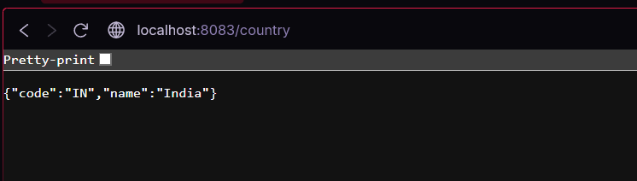

**5. JWT-handson**

**Q> Create authentication service that returns JWT**

AuthentiationController.java

package com.cognizant.spring_learn.controller;  
  
import com.cognizant.spring_learn.util.JwtUtil;  
import org.springframework.http.ResponseEntity;  
import org.springframework.web.bind.annotation.*;  
  
import java.util.Base64;  
  
@RestController  
public class AuthenticationController {  
  
 @GetMapping("/authenticate")  
 public ResponseEntity<?> authenticate(@RequestHeader("Authorization") String authHeader) {  
 // Basic base64encoded(user:pwd)  
 if (authHeader == null || !authHeader.startsWith("Basic ")) {  
 return ResponseEntity.*badRequest*().body("Missing or invalid Authorization header.");  
 }  
  
 String base64Credentials = authHeader.substring("Basic ".length());  
 byte[] decodedBytes = Base64.*getDecoder*().decode(base64Credentials);  
 String decodedCredentials = new String(decodedBytes);  
 String[] parts = decodedCredentials.split(":", 2);  
 String username = parts[0];  
 String password = parts[1];  
  
 // In a real app, validate username/password against DB or UserDetailsService here  
 if (!"user".equals(username) || !"pwd".equals(password)) {  
 return ResponseEntity.*status*(401).body("Invalid credentials");  
 }  
  
 String token = JwtUtil.*generateToken*(username);  
 return ResponseEntity.*ok*().body("{\"token\":\"" + token + "\"}");  
 }  
}

SecurityConfig.java

package com.cognizant.spring_learn.config;  
  
import org.springframework.context.annotation.Bean;  
import org.springframework.context.annotation.Configuration;  
import org.springframework.security.config.annotation.web.builders.HttpSecurity;  
import org.springframework.security.web.SecurityFilterChain;  
  
@Configuration  
public class SecurityConfig {  
  
 @Bean  
 public SecurityFilterChain filterChain(HttpSecurity http) throws Exception {  
 http  
 .csrf().disable()  
 .authorizeHttpRequests()  
 .requestMatchers("/authenticate").permitAll()  
 .anyRequest().authenticated()  
 .and()  
 .httpBasic();  
 return http.build();  
 }  
}

JWtUtil.java

package com.cognizant.spring_learn.util;  
  
import io.jsonwebtoken.Jwts;  
import io.jsonwebtoken.SignatureAlgorithm;  
  
import java.util.Date;  
  
public class JwtUtil {  
 private static final String *SECRET_KEY* = "secretkey";  
  
 public static String generateToken(String username) {  
 long nowMillis = System.*currentTimeMillis*();  
 long expMillis = nowMillis + (60 * 60 * 1000); // 1 hour expiration  
  
 return Jwts.*builder*()  
 .setSubject(username)  
 .setIssuedAt(new Date(nowMillis))  
 .setExpiration(new Date(expMillis))  
 .signWith(SignatureAlgorithm.*HS256*, *SECRET_KEY*)  
 .compact();  
 }  
}

pom.xml

<dependency>  
 <groupId>io.jsonwebtoken</groupId>  
 <artifactId>jjwt</artifactId>  
 <version>0.9.1</version>  
</dependency>  
  
<dependency>  
 <groupId>org.springframework.boot</groupId>  
 <artifactId>spring-boot-starter-security</artifactId>  
</dependency>